SALE, EXCHANGE AND REPURCHASE OF LPG GAS CYLINDERS AT ALEXELA GAS STATION SHOPS

AS Alexela sells / accepts only those cylinders that meet the conditions and quality requirements set by Alexela.

The following cylinders are sold and exchanged at AS Alexela gas stations:
Click On grill gas cylinders (with valve) are filled with a richer propane gas mixture, and are suitable for outdoor use even when you want to enjoy grilling at -10°C.

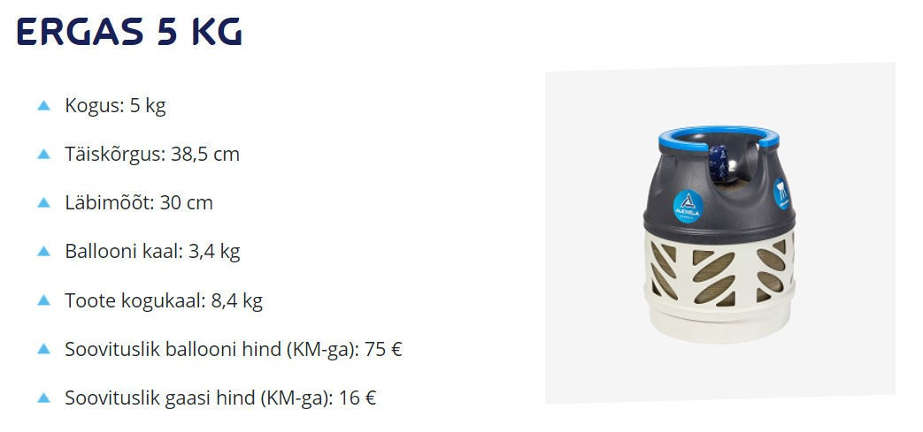

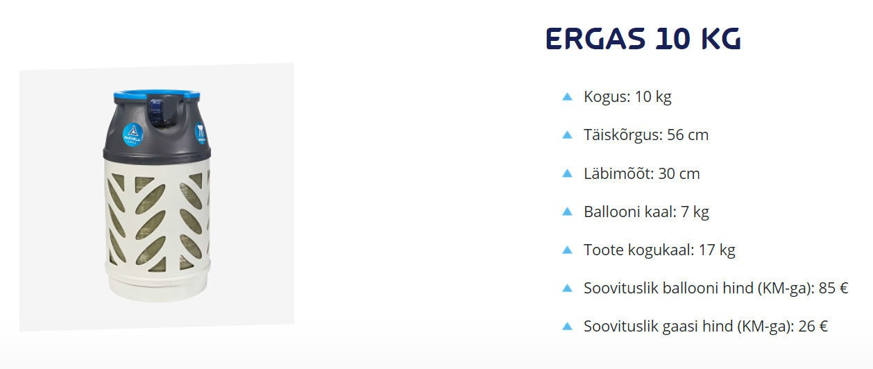

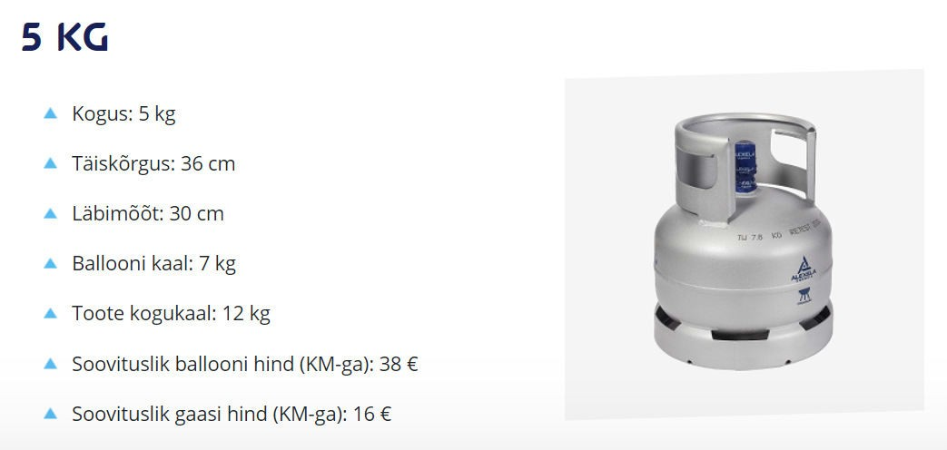

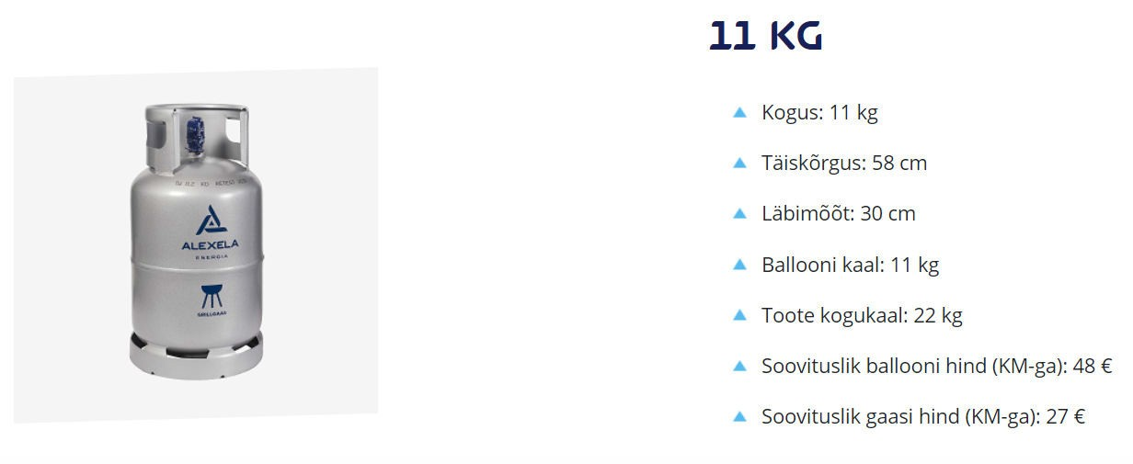

Household cylinders with an angle valve connection are filled with a safer gas mixture suitable for indoor use at temperatures above +10°C.
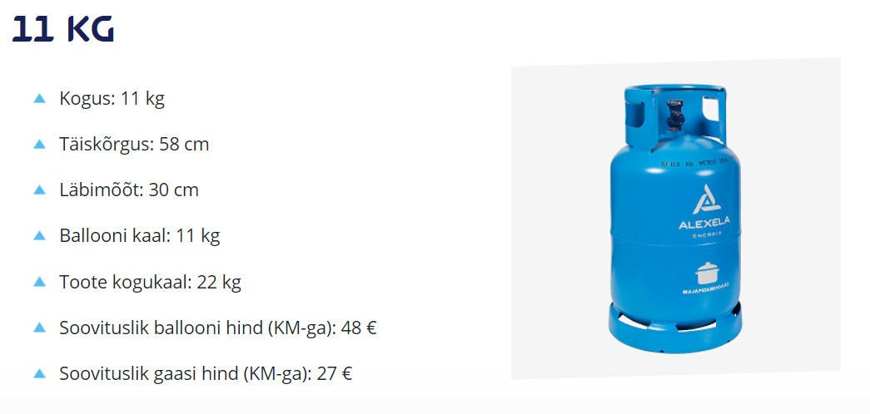

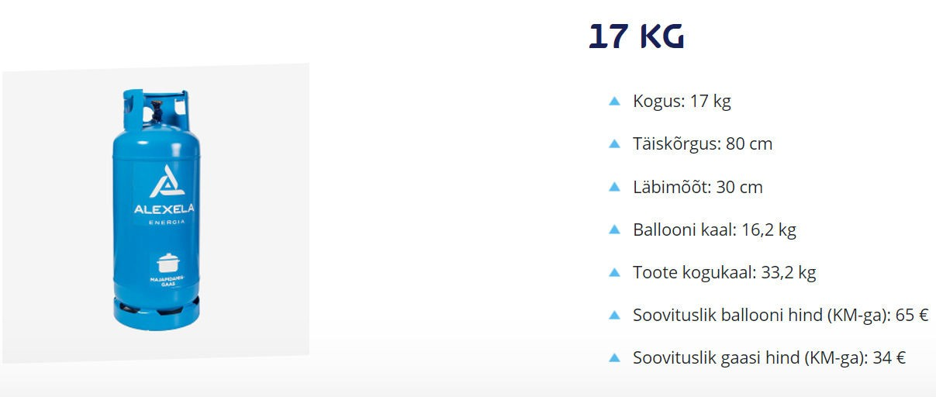

The gas cylinders include the following product labels

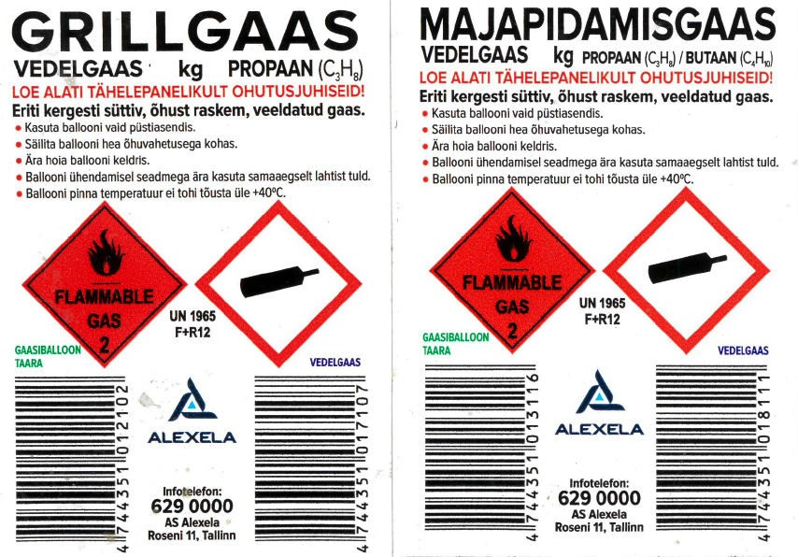

Reducers and hoses for use at temperatures between +50°C and -20°C are also on sale in Alexela AS gas stations.
Quick connection regulator / reducer
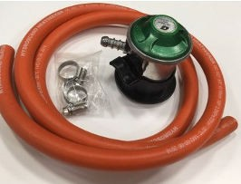

Pressure regulator/reducer with pressure gauge and quick connection
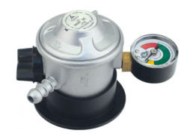

Instructions for installing the grill gas regulator (see the drawing below):
- Turn off the regulator – by turning the switch on the top of the controller to the OFF position.
- Take hold of the regulator with both hands, and push it, along with the locking ring, onto the cylinder valve.
- Free the locking ring, by pushing te regulator onto the cylinder, and push the locking ring firmly into the lower position
- To check the connection, try to lift the cylinder off the regulator. If the regulator detaches from the cylinder, reconnect it.
- To put the regulator into operating mode, turn the switch on top of the regulator to the ON position (i.e., in the same direction as the connection hose). Always turn the switch to the OFF position after use.
- To remove the regulator from the cylinder, turn the switch the OFF position, then lift the locking ring and remove the regulator from the cylinder valve.
- When connecting the LPG hose to the regulator, push the hose all the way onto the regulator nozzle and secure it with a clamp.
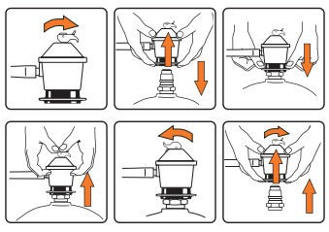

Proceed as follows when handling the gas regulator:
- When using cylinder gas, make sure the device is in good order.
- Before installing the regulator, make sure that the seal between the regulator and angle valve is in order. (If the gasket needs to be replaced, you will find a new gasket on the Alexela cylinder protection cap). Attach the regulator to a cylinder with an angle valve by turning the fastening nut in the counter clockwise direction.
- Open the cylinder valve and check the sealing of the connections with soap foam.

Requirements for returning/replacing cylinders:
- The cylinder must have a Pi-Marking. Plastic cylinders usually have a marking pressed into the collar/handle of the cylinder. On metal cylinders, it is on the handle or around the valve.
- The cylinder must be intact without any mechanical damage.
- The cylinder must not have any traces of melting or burning.
- The cylinder must not be damaged by paint.
- The cylinder must have a valve attached.
- The cylinder ei tohi olla väljaspool Eestit ega ka väljaspool Eestit märgistust.
- The cylinder must not differ in appearance, shape or size and height from the above images.
- The colour of the cylinder should be the same, but if the other conditions (shape, size, Pi Marking) meet the requirements, the exchange can also be made.
- Cylinder exchanges can only be made with cylinders of the same volume, except when the cylinder volume is being exchanged against another volume or type, as described below:
  - Cylinders can be exchanged for smaller or larger capacity cylinders (for example: a 5kg cylinder exchanged for 11kg one or vice versa).
  - A metal grill cylinder exchanged for a composite cylinder (for example: a 11kg metal grill cylinder exchanged for 10kg composite one or vice versa).
  - Exchanges can only be made with Alexela (Reola Gaas) brand cylinders.
  - The returned cylinder must meet the requirements specified under “Requirements for returning/replacing cylinders“.

- We will also buy back empty cylinders if you no longer need them, and do not want to exchange them for another size. However, the buyback price will be half of the cylinder’s list price.
  - Buybacks can only be made with Alexela (Reola Gaas) brand cylinders
  - Only half (50%) of the price of a new cylinder will be paid when buying back cylinders.
  - The returned cylinder must meet the requirements specified under “Requirements for returning/replacing cylinders“.

- Alexela accepts old propane and propane-butane cylinders (including unusable, non-compliant, broken cylinders, those of competitors and the old Russian red cylinder) free of charge, if there is no possibility of disposing them elsewhere. But only if there is sufficient space in the cylinder cabinet of the service station, where they can be stored until being hauled away.
- Alexela does not accept medical/industrial gas cylinders (e.g., acetylene, oxygen, nitrogen etc.).

Safety requirements for cylinders:
- The refuelling of cylinders and containers is strictly prohibited at Alexela gas stations.
- Cylinders must be kept upright, as liquefied gas can leak from a cylinder if it is placed on its side, and if it changes to a gaseous state, it can become a serious hazard.
- The LPG cylinder must be kept in a place where the temperature does not rise above +40°C.
- It is prohibited to repair the cylinder or its valve, to look for a gas leak with a flame or leave a leaking cylinder indoors.
- When transporting the cylinder, make sure the valve is closed and capped, and that the cylinder is always in an upright position and fixed to prevent it from rolling. The maintenance and repair of gas equipment may only be performed by specialists working for company that are licensed to work on gas equipment.

Failure to follow these instructions could result in damage to people as well as property (risk of poisoning, explosion and frostbite).

Safety requirements for the use of the cylinder:
When igniting the flame, open the cylinder valve. If the gas appliance (grill, stove, heater, etc.) does not have a built-in ignition system, ignite the burner with a match or a special igniter.
When extinguishing the flame, first turn off the gas tap. If you don’t plan to use the gas appliance for a while, it is better to close the cylinder valve as well. When the valve is closed, the flame in the gas appliance should go out. If it does not, immediately close the gas tap and call a specialist from a licensed gas company.

Customer service:
Open Mon-Fri 8:30 am -5:00 pm
Contact information: +372 629 0000; alexela@alexela.ee; Roseni 11, 10111 Tallinn
AS Alexela; Reg. nr. 10015238; KMKR nr. EE100281017

